Lab: The User Interface Architecture

In this lab, you will make some usability improvements to the "Phone & Addresses" card on the Details screen. To view the card, click the Details screen link, and then click the "Phone & Addresses" card.

Tasks

1. Move the Fax Phone widget so that it appears below the Work Phone widget.

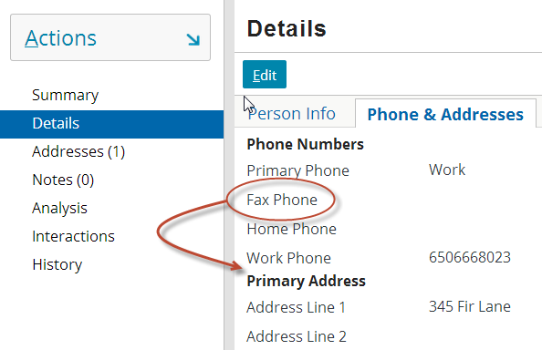

1. Add an input divider directly above the "Primary Address" label so that the phone and address sections have a clearer visual separation.

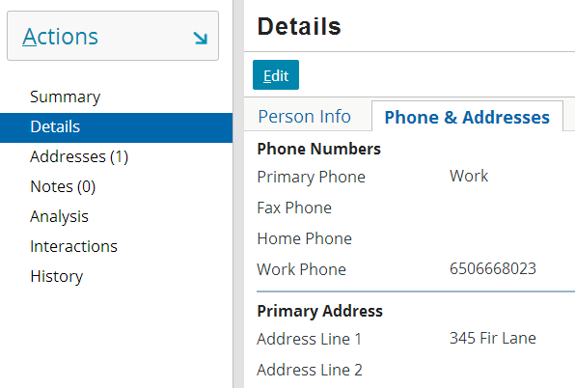

|  |  |
| --- | --- |
|  | **Stop and ask your instructor to review your completed lab or compare your PCF file with the one provided in the solutions.** |